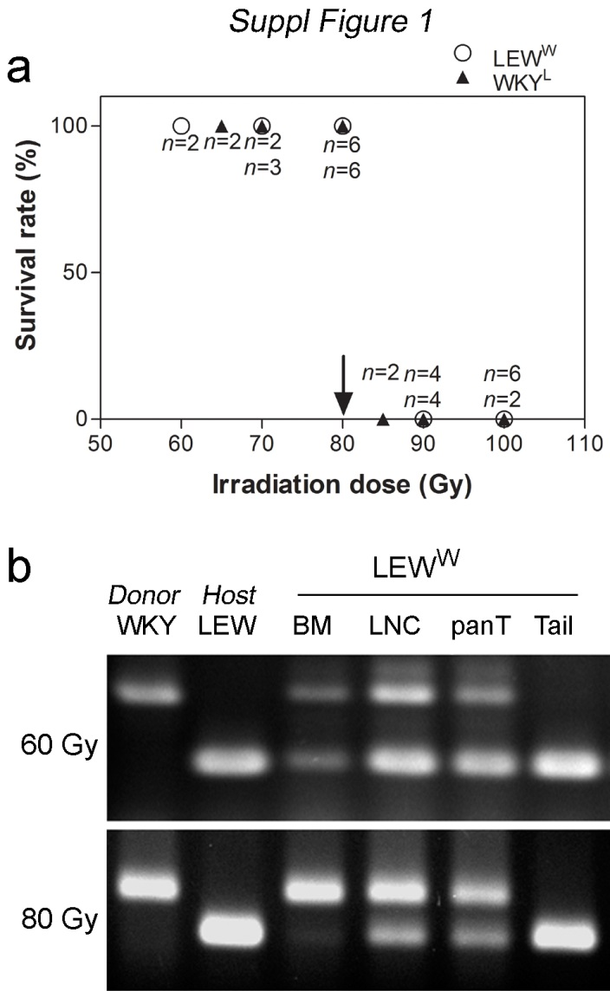
Supplementary Figure 1. Characterization of bone marrow (BM) chimeras between WKY and LEW rats. (a) Irradiation dose-dependent mortality for determination of optimal dosage for creation of BM chimera. Arrow indicates the maximal survival dose. (b) Determination of origins of various tissues/cells from chimera irradiated at 60 or 80 Gy in representative LEW^{W} chimeras by PCR-based genotyping using polymorphic microsatellite DNA as probes. BM, bone marrow; LNC, lymph node cells; panT, pan T cells from PBL. Results for microsatellite D3R201 are shown; other two are similar.

