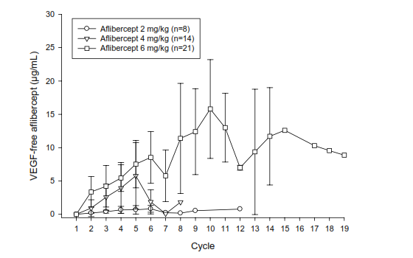 Suppl. Fig. 1. Mean (± standard deviation) free aflibercept C_{trough} profiles. C_{trough} = Plasma concentration before starting the infusion at each treatment cycle.

