Supporting information
Supplementary Table 1 Primer sequences for real-time qPCR

Primer | Sequence (5’ to 3’)
Oct4-F | TGGGCTCGAGAAGGATGTG
Oct4-R | GCATAGTCGCTGCTTGATCG
Sox2-F | CCCCCGGCGGCAATAGCA
Sox2-R | TCGGCGCCGGGGAGATACAT
Nanog-F | CAGAAGGCCTCAGCACCTAC
Nanog-R | GTCACTGGCAGGAGAATTTGG
Cdx2-F | CCTCCGCTGGGCTTCATTCC
Cdx2-R | TGGGGGTTCTGCAGTCTTTGGTC
Brachyury-F | TGCTTCCCTGAGACCCAGTT
Brachyury-R | GATCACTTCTTTCCTTTGCATCAAG
Pax6-F | CAGCTCGGTGGTGTCTTTG
Pax6-R | AGTCGCTACTCTCGGTTTA
GAPDH-F | GTCAACGGATTTGGTCGTATTG
GAPDH-R | CATGGGTGGAATCATATTGGA

Supplementary Table 2 Purification of hbFGF fusion proteins from recombinant expression in E. coli with different expression vectors and expression hosts with HiTrap Heparin HP column chromatography.
Expression vector | Expression Host | Fraction | Total protein (mg)¹ | hbFGF fusion protein (mg)^{1,2} | Purity (%)³ | Yield (%)⁴
pET28/hbFGF | BL21(DE3) | Cell lysate | 105.7 | 13.8 | 13.1 | 100
 |  | Soluble protein | 84.6 | 13.6 | 16.1 | 98.6
 |  | 0.5 M NaCl | 3.5 | 0 | 0 | 0
 |  | 1 M NaCl | 0 | 0 | 0 | 0
 |  | 2 M NaCl | 13.1 | 12.4 | 94.7 | 90
 | ArticExpress | Cell lysate | 117.4 | 13.4 | 11.4 | 100
 |  | Soluble protein | 92.8 | 12.9 | 13.9 | 96.3
 |  | 0.5 M NaCl | 2.8 | 0 | 0 | 0
 |  | 1 M NaCl | 0 | 0 | 0 | 0
 |  | 2 M NaCl | 12.9 | 12.2 | 94.6 | 91
pET32/hbFGF | BL21(DE3) | Cell lysate | 123.7 | 18.9 | 15.3 | 100
 |  | Soluble protein | 96.5 | 17.6 | 18.2 | 93.1
 |  | 0.5 M NaCl | 3.9 | 0 | 0 | 0
 |  | 1 M NaCl | 1.8 | 1.8 | 100 | 9.5
 |  | 2 M NaCl | 15.2 | 14.8 | 97.3 | 78.3
 | ArticExpress | Cell lysate | 135.2 | 21.7 | 16.1 | 100
 |  | Soluble protein | 107.8 | 20.3 | 18.8 | 93.5
 |  | 0.5 M NaCl | 3.3 | 0 | 0 | 0
 |  | 1 M NaCl | 4.7 | 4.7 | 100 | 21.7
 |  | 2 M NaCl | 14.7 | 14.2 | 96.6 | 65.4

¹ Results are derived from 1 g of wet cell weight. Protein concentrations were estimated by the method of Bradford with bovine serum albumin (BSA) as a standard.
² The amount of hbFGF fusion protein was calculated from the ratio of the intensity of the target protein band to the intensity of all protein bands in the fraction. The band intensity was analyzed with Quantity One software.
³ The % Purity was determined by dividing the amount of the target protein by that of the total proteins in each fraction and multiply by 100.
⁴ The yield at each step in the procedure is the amount of the target protein at that step divided by the amount of the target protein in the first step (defined as 100%).
Supplementary Table 3 Purification of hbFGF fusion proteins from recombinant expression in E. coli with different expression vectors and expression hosts by IMAC on a HisTrap HP column.
Expression vector | Expression Host | Fraction | Total protein (mg)¹ | hbFGF fusion protein (mg)^{1,2} | Purity (%)³ | Yield (%)⁴
pET28/hbFGF | BL21(DE3) | Cell lysate | 108.3 | 10.2 | 9.4 | 100
 |  | Soluble protein | 84.6 | 9.6 | 11.3 | 94.1
 |  | 100 mM Imidazole | 0.5 | 0.4 | 80 | 3.9
 |  | 250 mM Imidazole | 0.3 | 0.3 | 100 | 2.9
 |  | 500 mM Imidazole | 0.3 | 0.3 | 100 | 2.9
 | ArticExpress | Cell lysate | 115.7 | 12.6 | 10.9 | 100
 |  | Soluble protein | 95.4 | 11.9 | 12.5 | 94.4
 |  | 100 mM Imidazole | 1.2 | 0.7 | 58.3 | 5.5
 |  | 250 mM Imidazole | 0.5 | 0.5 | 100 | 4
 |  | 500 mM Imidazole | 0.4 | 0.4 | 100 | 3.1
pET32/hbFGF | BL21(DE3) | Cell lysate | 119.1 | 14.9 | 12.5 | 100
 |  | Soluble protein | 96.5 | 14.4 | 14.9 | 96.6
 |  | 100 mM Imidazole | 3.5 | 3.1 | 88.6 | 20.8
 |  | 250 mM Imidazole | 1.2 | 1.2 | 100 | 8.1
 |  | 500 mM Imidazole | 0.5 | 0.5 | 100 | 3.4
 | ArticExpress | Cell lysate | 125.1 | 15.7 | 12.5 | 100
 |  | Soluble protein | 102.2 | 15.4 | 15.1 | 98.1
 |  | 100 mM Imidazole | 4.2 | 3.5 | 83.3 | 22.3
 |  | 250 mM Imidazole | 0.9 | 0.9 | 100 | 5.7
 |  | 500 mM Imidazole | 0.4 | 0.4 | 100 | 2.5

¹ Results are derived from 1 g of wet cell weight. Protein concentrations were estimated by the method of Bradford with bovine serum albumin (BSA) as a standard.
² The amount of hbFGF fusion protein was calculated from the ratio of the intensity of the target protein band to the intensity of all protein bands in the fraction. The band intensity was analyzed with Quantity One software.
³ The % Purity was determined by dividing the amount of the target protein by that of the total proteins in each fraction and multiply by 100.
⁴ The yield at each step in the procedure is the amount of the target protein at that step divided by the amount of the target protein in the first step (defined as 100%).

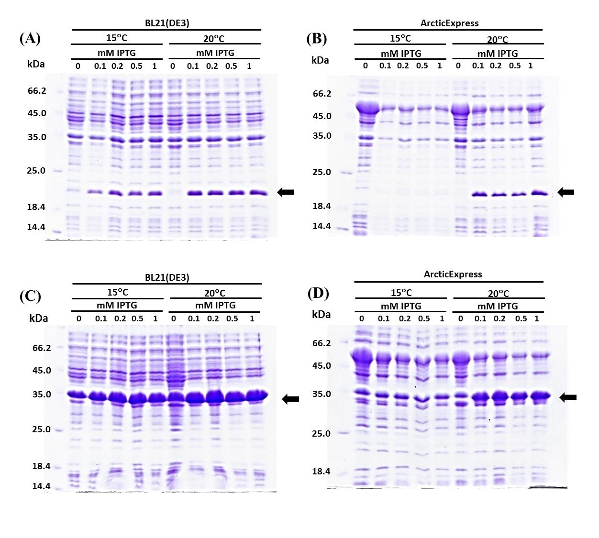
Supplementary Figure 1 Effect of host cell, induction temperature and IPTG concentration on expression of recombinant hbFGF fusion proteins. The pET28/hbFGF (A and B) and pET32/hbFGF (C and D) expression vectors were transformed into E. coli BL21(DE3) (A and C) and ArticExpress strains (B and D). The transformed cells were grown at 37°C to an OD600 of 0.6 and then induced with 0 to 1 mM IPTG for 12 h at 15 or 20°C. The induced cells were harvested, the whole cell lysate was analyzed on 15% SDS-PAGE and the gels stained with Coomassie Brilliant Blue. Proteins from equal amount of cells were loaded into each lane. The arrows indicate the positions of recombinant fusion proteins.

Supplementary Figure 2 The effect of induction times on solubility of recombinant hbFGF fusion proteins. The pET28/hbFGF(A and B) and pET32/hbFGF (C and D)expression vectors were transformed into E. coli BL21(DE3) (A and C) and ArticExpress(DE3) (B and D) strains. The transformed cells were grown at 37°C to an OD600 of 0.6 and then induced with 0.2 mM IPTG for 6 to 24 h at 20°C. The induced cells were harvested and then the cell lysates were separated into soluble and the insoluble fraction by centrifugation. The solubility of the fusion proteins was analyzed on 15% SDS-PAGE and the gels stained with Coomassie Brilliant Blue. Equal cell concentration was loaded into each lane. The arrows indicate the position of recombinant fusion proteins. (-), total protein before induction; T, total cellular protein after induction; IS, insoluble fraction from induced cells; S, soluble fraction from induced cells.

Supplementary Protocol for production and purification of recombinant hbFGF fusion proteins (Trx-6xHis-hbFGF)
Reagents:
1. LB medium with 100 μg ml⁻¹ampicillin.
2. Lysis/binding buffer: 50 mM sodium phosphate buffer (pH 8.0) (Sambrook et al., 1989), 1 mM phenylmethylsulfonyl fluoride (PMSF), 150 mM NaCl, 0.1% Triton X-100, 10% glycerol, 2 mM imidazole and 200 µg ml⁻¹ lysozyme.
3. Washing buffer: 50 mM sodium phosphate buffer (pH 8.0), 1 mM PMSF and 150 mM NaCl
4. HiTrap Heparin HPcolumn (GE Healthcare, 17-0406-01).
Procedure:
Day 1
Take a single colony of BL21(DE3) containing plasmid pET32/hbFGF and inoculate into 5 ml LB medium with ampicillin shake at 250 rpm at 37°Cover night
Day 2
1. Next morning dilute 1:100 in 200 ml LB medium with ampicillin and grow the cells at 37°C shaking at 250 rpm to mid-log phase (OD_{600 nm} approximately 0.6).
2. Adjust the temperature of the incubator to 20°C which will take about 30 min and then induce the protein production by add IPTG (0.2mM final concentration). Incubate the culture at 20°C with shaking at 250 rpm.
Day 3 onward
1. After 18 h of induction, spin down the culture at 4000xg for 20 min. The cell pellets should be kept frozen at -70°C until use or at least overnight.
2. Re-suspend the cell pellets in 20 ml lysis/binding buffer and incubate at 37°C for 15 min. Cool the cells in an ice bucket and sonicate with a tip sonicator on setting 60-80% amplitude, 60% cycle duty (sonicates 10 sec, stop 5 sec then repeat the cycle) for 15 min. Try and avoid foaming if possible and keep on ice.
3. Separate the soluable and insoluable fractions by centrifugation at 11,700×g, 4°C for 10 min. Then filter the cell suspension to obtain soluble fraction through 0.45 μm polyethersulfone membrane before chromatography.
4. Prepare a HiTrap Heparin HP column (GE Healthcare, 17-0406-01) by wash the column with 10 column volumn of washing buffer
5. Apply the soluble fraction to the pre-equilibrate HiTrap Heparin HP and wash the column with 10 ml of washing buffer then elute the bound fusion protein (Trx-6xHis-hbFGF) with step gradient of 5 ml of washing buffer containing 0.5 M, 1M and 2M NaCl. The fusion protein usually elutes between 1 and 2 mM NaCl.
6. Identify fractions containing the fusion protein and purity by SDS-PAGE. The purified Trx-6xHis-hbFGF fusion proteins displayed molecular mass of 35 kDa.
7. Pool the fractions containing fusion protein and concentrate the sample using Amicon® Ultra-15, MWCO 10 kDa filters (Amicon, Z706345) according to the manufacturer’s instructions.
8. Determined the protein concentrations using Bradford method. Then mix the purified protein with human serum albumin (0.1% final concentration) and filtered through a 0.2 μm syringe filter. Prepares 0.5-1 ml aliquots and stored at 4°C or -20°C for further use.

Cost analysis of recombinant hbFGF fusion protein production.
Detail | Cost estimation ($ USD):  one batch culture (1 liter) | Remark
Materials
- LB medium | 5
- Buffer solution | 5
- HiTrap Heparin HP column | 45/5 | Reusable (reused 5x)
- Amicon® Ultra-15 | 10
Consumables | 10
Labor | 31
Total | 70 | Yield 80 mg of  Trx-6xHis-hbFGF

Remark: Following the protocol above, we were able to produce recombinant hbFGF with $ USD 0.88/1 mg of recombinant hbFGF fusion protein. It is a cost effective protocol when compare with commercial available that is approximately $2,800 - 21,000/1 mg of recombinant hbFGF (when buy in Thailand the bFGF is 7650 Baht per 10 ug which is about $ USD 21,000 per mg). This study, we demonstrated an easy and efficient expression system for in-house hbFGF production that is cheaper that the commercials around 40-300 time depend on the amount bought from company.

