Online Supplementary Materials

Supplementary Fig. 1. Mitochondrial biogenesis upon donepezil treatment assessed by MitoTracker assay
SK-N-MC cells were treated with various concentrations of donepezil for 24 hr, and mitochondrial masses were determined using the MitoTracker assay.

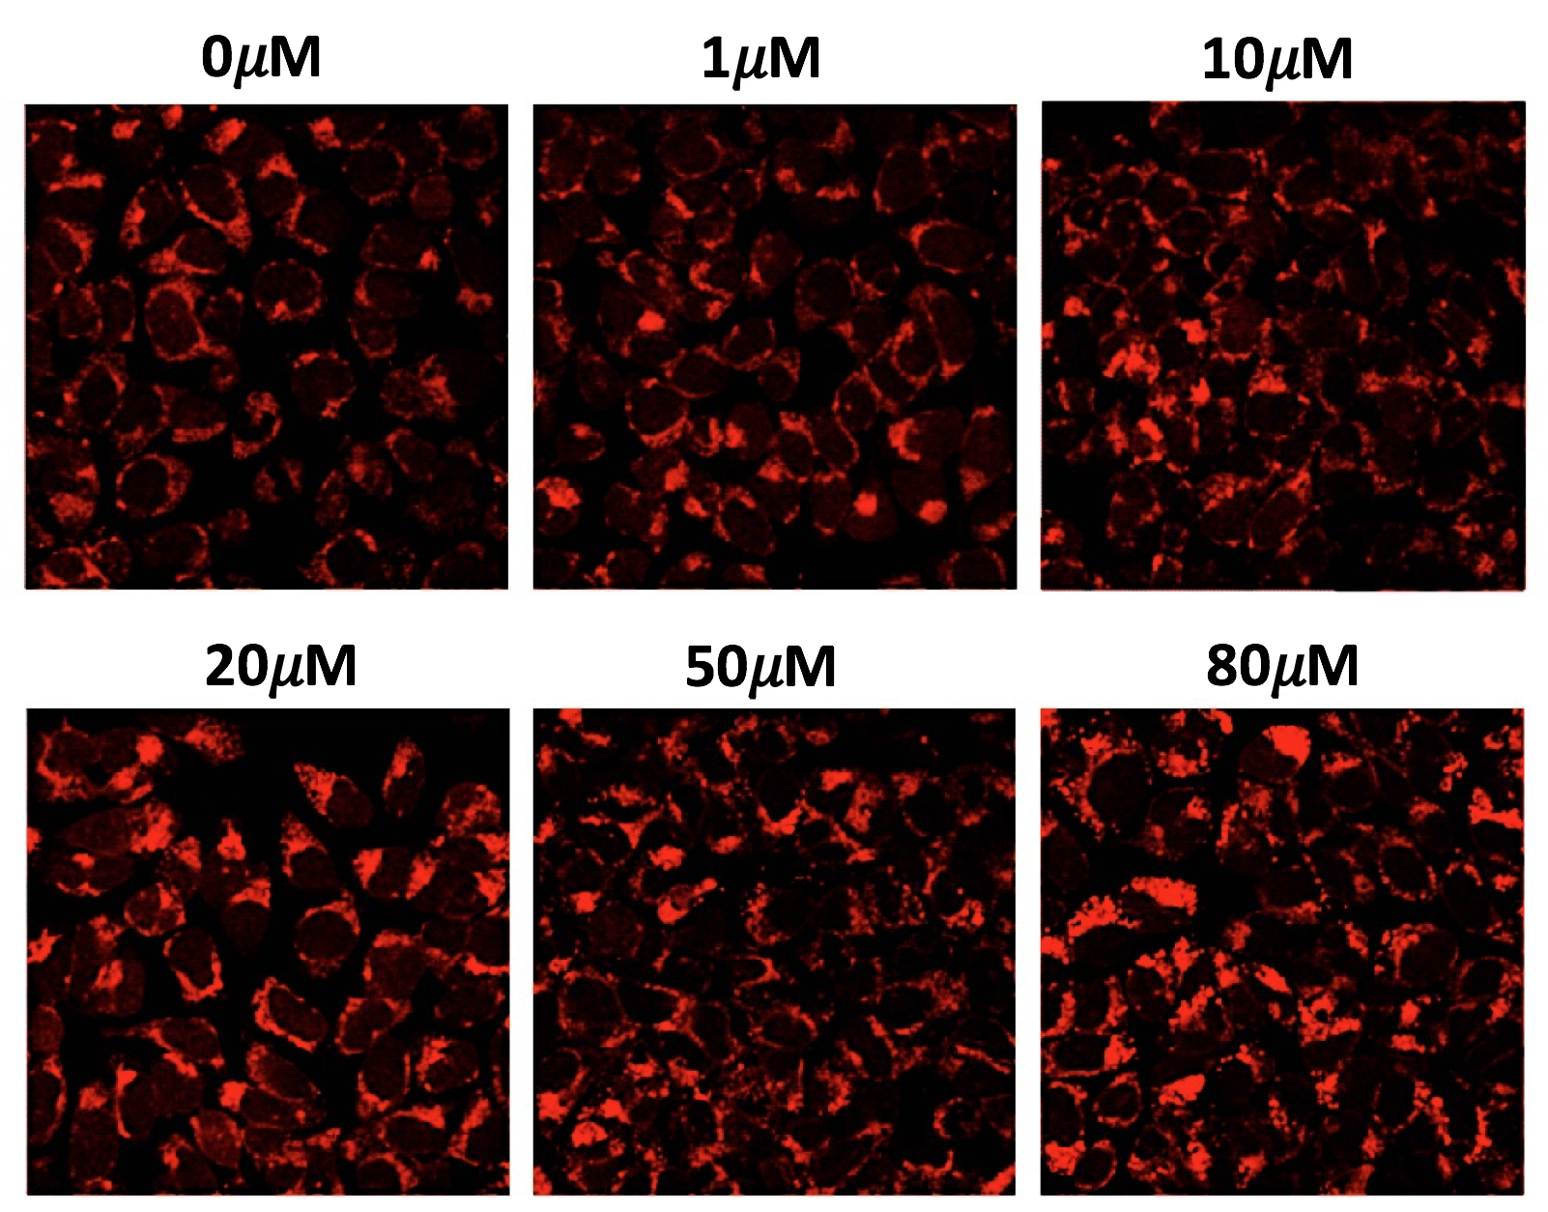

Supplementary Fig. 2. Donepezil activates AMPK in a dose-dependent manner
Activation of AMPK was determined using Western blotting with anti-phospho-AMPK (Thr172) and anti-phospho-ACC (Ser79) upon treatment of various doses of donepezil. * p<0.05 compared with 0μM (n=3). Values represent mean±SE.

Supplementary Fig. 3. MitoTracker assay for the changes in mitochondrial biogenesis in response to AMPK activator or inhibitor
SK-N-MC cells were treated with either of donepezil or AICAR for 24 hr, and CC was co-treated during the final 6 hr. CC effectively suppressed both donepezil- and AICAR-induced mitochondrial biogenesis, suggesting AMPK involvement in the action of donepezil. CC, compound C.
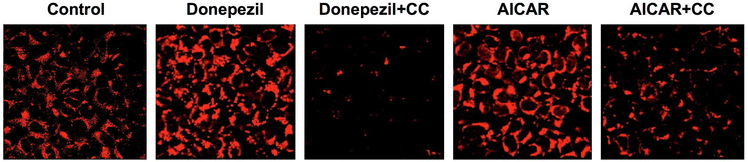

Supplementary Fig. 4. Donepezil enhances AMPK activity and mitochondrial biogenesis in ex vivo hippocampal tissue cultures of adult mouse.
(a-b) Organic hippocampal slice cultures were treated with 20µM donepezil for 24 hr. A subset of donepezil-treated slices was co-treated with 10µM of CC, an AMPK inhibitor, during the final 6 hr. Hippocampal tissue cultures were processed for immunohistochemistry using anti-phospho-AMPK (Thr172; green), MitoTracker (red) and DAPI (blue). Many active forms of AMPK and functional mitochondria were populated in the neuronal layers of CA1, CA3, and the dentate gyrus (DG) of hippocampal tissue treated by donepezil. This effect was blocked by co-treatment with CC. DAPI was used to help visualize the layer structure of the hippocampus. Scale bar 50µm. Data represent mean±SE (n=5) of relative intensity compared with the non-treated hippocampal tissue. *p<0.05 compared with 0μM; #p<0.05 when compared with donepezil alone.

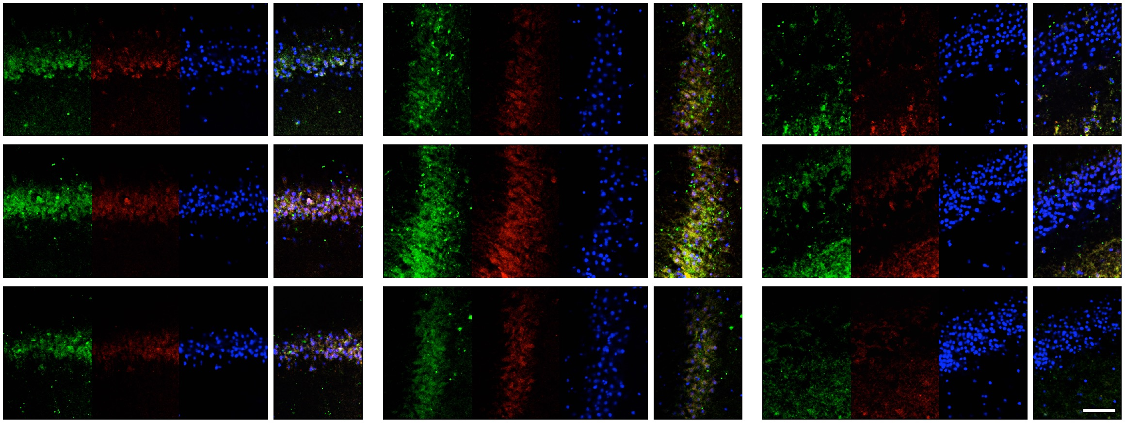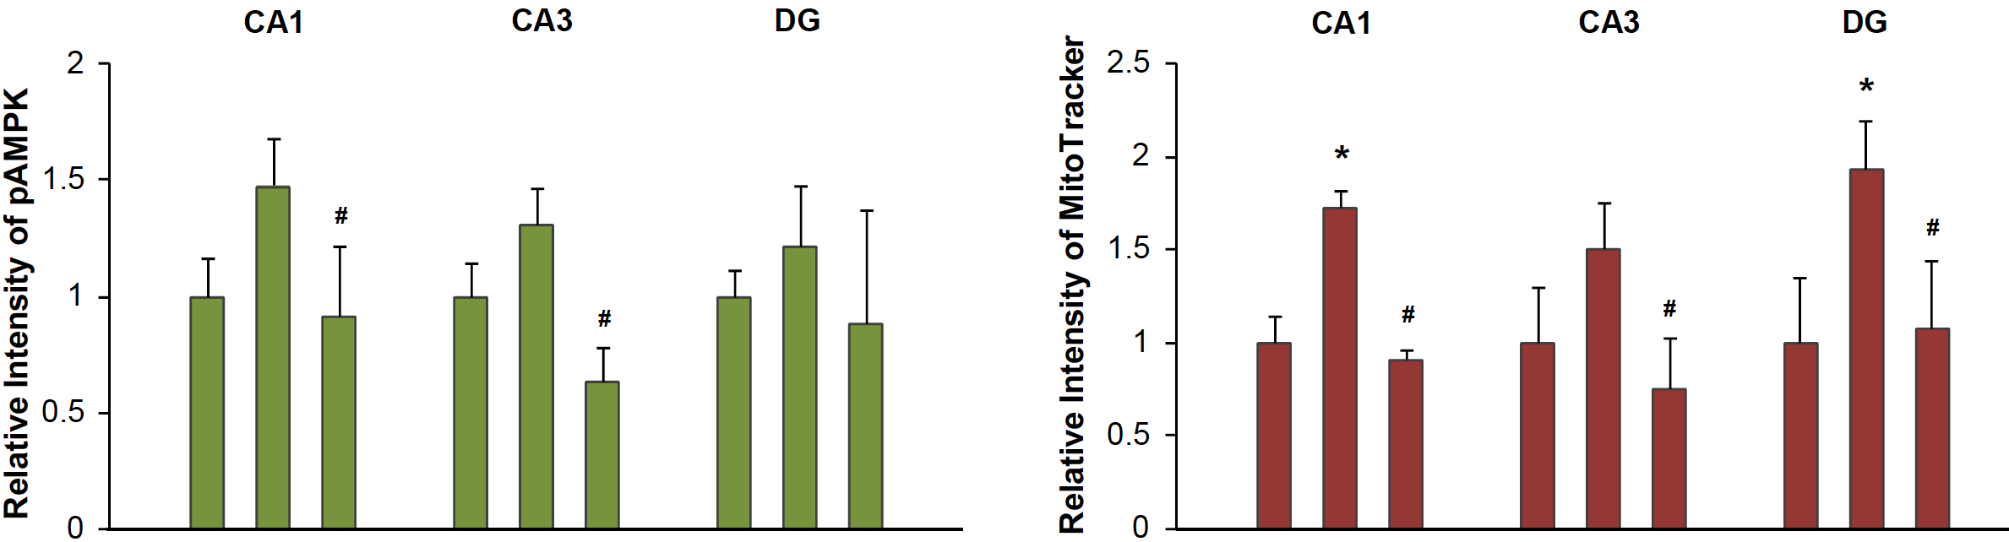
Donepezil
Compound C
-
-
+
-
+
+
-
-
+
-
+
+
-
-
+
-
+
+
-
-
+
-
+
+
-
-
+
-
+
+
-
-
+
-
+
+
Donepezil
Compound C
pAMPK
MT
DAPI
Merged
pAMPK
MT
DAPI
Merged
pAMPK
MT
DAPI
Merged
Donepezil
+
Compound C
Donepezil
Control
CA1
CA3
DG
(a)
(b)
(c)

