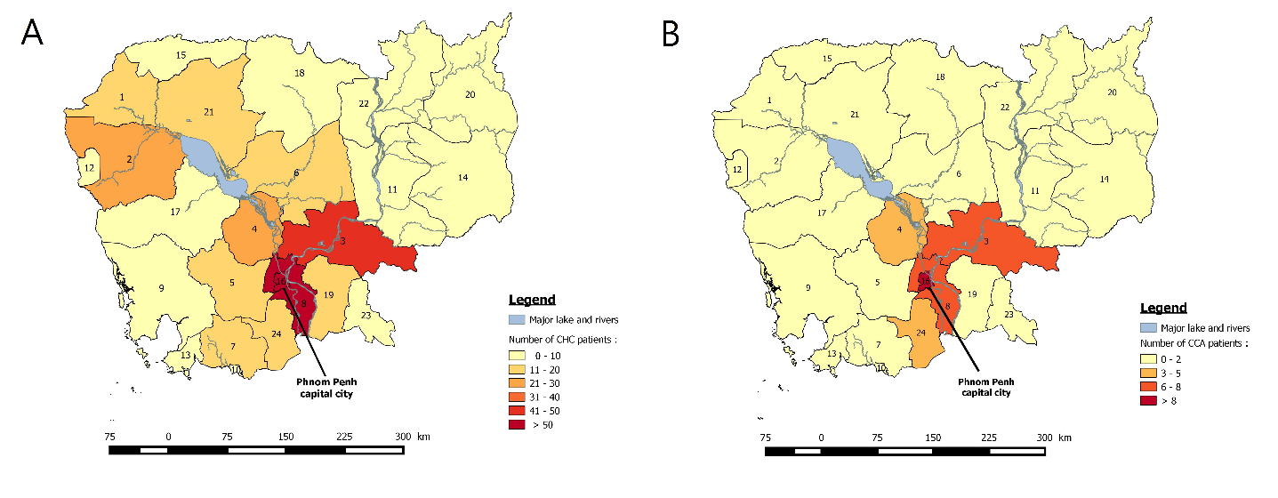

**Fig. S1. Regional distribution of patients with HCC (A) and CCA (B) attending the Calmette Hospital between 2003 and 2015.** The numbers on the choropleth maps indicate the provinces classified as follow: (**1**) Banteay Meanchey [n=15 (HCC);1(CCA)]; (**2**) Battambang (29;0); (**3**) Kampong Cham (46;6); (**4**) Kampong Chhnang (24;3); (**5**) Kampong Speu (17;1); (**6**) Kampong Thom (16;0); (**7**) Kampot (11;0); (**8**) Kandal (59;6); (**9**) Koh Kong (3;0); (**10**) Kep (0;0); (**11**) Kratie (9;1); (**12**) Pailin (3;1); (**13**) Preah Sihanouk (9;0); (**14**) Mondulkiri (1;0); (**15**) Otdar Meanchey (2;0); (**16**) Phnom Penh (197;13); (**17**) Pursat (7;1); (**18**) Preah Vihear (3;2); (**19**) Prey Veng (20;1); (**20**) Ratanakiri (2;1); (**21**) Siem Reap (14;0); (**22**) Stung Treng (2;0); (**23**) Svay Rieng (7;1); and (**24**) Takeo (15;4).