SUPPLEMENTAL MATERIAL

Supplemental Methods:
The Health Improvement Network (THIN): Additional Information.
This data source represents a large sample (5.7%) of the general population of the UK in an outpatient setting with diverse representation of age, sex, socioeconomic status, and geography (1). Every patient in the UK must be registered with a general practitioner who coordinates all care, writes all prescriptions, including those recommended by specialists, and is informed of events in the patient’s care. The data contain demographics (excluding race), diagnoses, procedures, laboratory and radiology results, blood pressure, BMI, prescription data, hospitalization data, socioeconomic status, and death certificate data (see Supplemental Methods for additional information) (1). Completeness of the medical record is now tied to reimbursement through a pay-for-performance program, which corresponds to improved adherence to quality measures including ambulatory blood pressure monitoring for confirmation of the diagnosis of hypertension, waist circumferences measurements in obese patients, and screening for proteinuria (2, 3). With regard to prescribing data, the database captures prescriptions as they are issued to patients (4, 5). The date associated with each medication reflects the date in which the actual prescription was ordered. The accuracy and completeness of the prescribing data have been well-validated previously (6, 7). The database also includes free text of supplemental information such as kidney biopsy results and descriptive information related to death data. Medications use to define patient exposures were identified using the British formulary to identify a comprehensive list of drug codes in the THIN database.
In order to be eligible for initial inclusion in the study, we required that patients be registered with a THIN practice for a minimum of 6 months. This 6 month post-registration index date was based on protocols developed in previous studies using THIN, intended to ensure that data collected did not capture incorporation of preceding medical events and diagnoses into the health record (8). With regard to exit from the cohort, patients were censored at the time of transfer out of the practice or loss to follow up (defined as 18 months with no physician visits or prescriptions). UK general practitioners routinely record when patients transfer out of their practices, and transfer date is reliably captured as part of the THIN dataset (9). Transfer date in THIN has been used in many previous studies for defining the end of follow up or exit from the cohort (10-16). Additionally, the UK’s National Institute for Health and Care Excellence (NICE) recommends that all patients in the UK with hypertension be seen a minimum of once annually (3), and prescriptions in the UK expire after a maximum of six months (17). Thus, we selected 18 months of inactivity in the medical record as a conservative estimate of loss to follow up.

Statistical Power:
There was 90% power to detect a hazard ratio of 0.91 at a 0.05 significance level among patients who met eligibility criteria for the primary analyses (18, 19), indicating sufficient power to detect a very small statistically significant effect.

Supplemental Table 1. Baseline and Time-Updated Covariates Incorporated into each Model.

 | Traditional Cox Model | Marginal Structural Model
Baseline Covariates | Age | Age
 | Gender | Gender
 | Townsend Deprivation Index (20) | Townsend Deprivation Index (20)
 | Cardiovascular Disease Diagnosis | Cardiovascular Disease Diagnosis
 | Congestive Heart Failure Diagnosis | Congestive Heart Failure Diagnosis
 | Hepatitis B Virus Diagnosis | Hepatitis B Virus Diagnosis
 | Hepatitis C Virus Diagnosis | Hepatitis C Virus Diagnosis
 | Body Mass Index | Body Mass Index
 | Systolic Blood Pressure
 | Number of Antihypertensive Medications
 | Treatment with Mineralocorticoid Antagonist
 | Treatment with Diuretic
 | eGFR (CKD-EPI)
Time-Updated Covariates |  | Systolic Blood Pressure
 |  | Number of Antihypertensive Medications
 |  | Treatment with Mineralocorticoid Antagonist
 |  | Treatment with Diuretic
 |  | Development of Diabetes Diagnosis
 |  | eGFR (CKD-EPI)

Supplemental Table 2. Effect of Exposure to RAS Blockade on Mortality Using Multivariable Cox Model vs. Marginal Structural Modeling.
 |  | Multivariable Cox Model* |  | Marginal Structural Model†
 | Patients (n) | HR (95% CI) | p-value | HR (95% CI) | p-value
Overall | 219,701 | 1.03 (0.99-1.07) | 0.105 | 0.91 (0.81-1.02) | 0.112
+ CKD | 52,637 | 1.07 (1.01-1.13) | 0.024 | 0.94 (0.79-1.12) | 0.479
- CKD | 167,064 | 1.00 (0.95-1.06) | 0.937 | 0.90 (0.76-1.06) | 0.189
Overall proteinuria subgroup | 55,963 | 1.03 (0.95-1.11) | 0.451 | 0.96 (0.76-1.21) | 0.716
+ Proteinuria and + CKD | 564 | 0.77 (0.33-1.82) | 0.558 | 0.69 (0.16-2.97) | 0.621
- Proteinuria and + CKD | 16,141 | 1.02 (0.91-1.13) | 0.747 | 0.86 (0.62-1.19) | 0.362
- Proteinuria and - CKD | 39,258 | 1.04 (0.93-1.16) | 0.489 | 1.12 (0.83-1.52) | 0.463

Supplemental Table 3. Effect of Exposure to RAS Blockade on Development of Diabetes Using Multivariable Cox Model vs. Marginal Structural Modeling.
 |  | Multivariable Cox Model* |  | Marginal Structural Model†
 | Patients (n) | HR (95% CI) | p-value | HR (95% CI) | p-value
Overall | 219,701 | 0.944 (0.92-0.97) | < 0.001 | 0.847 (0.81-0.88) | < 0.001
+ CKD | 52,637 | 0.952 (0.90-1.00) | 0.068 | 0.855 (0.79-0.93) | < 0.001
- CKD | 167,064 | 0.942 (0.92-0.97) | < 0.001 | 0.824 (0.79-0.86) | < 0.001
Overall proteinuria subgroup | 55,963 | 0.921 (0.88-0.96) | < 0.001 | 0.831 (0.77-0.90) | < 0.001
+ Proteinuria and + CKD | 564 | 1.048 (0.74-1.48) | 0.789 | 0.946 (0.49-1.84) | 0.871
- Proteinuria and + CKD | 16,141 | 0.893 (0.82-0.98) | 0.012 | 0.874 (0.75-1.01) | 0.073
- Proteinuria and - CKD | 39,258 | 0.929 (0.88-0.98) | 0.004 | 0.813 (0.74-0.89) | < 0.001

Supplemental Table 4. Effect of Exposure to RAS Blockade on Death-Censored Renal Outcomes (50% Reduction in eGFR or ESRD) Using Multivariable Cox Model vs. Marginal Structural Modeling.

 |  | Multivariable Cox Model* |  | Marginal Structural Model†
 | Patients (n) | HR (95% CI) | p-value | HR (95% CI) | p-value
Overall | 219,701 | 1.18 (1.10-1.26) | < 0.001 | 1.17 (1.08-1.27) | < 0.001
+ CKD | 52,637 | 1.25 (1.13-1.38) | < 0.001 | 1.22 (1.08-1.38) | 0.001
- CKD | 167,064 | 1.14 (1.05-1.25) | < 0.001 | 1.24 (1.12-1.38) | < 0.001
Overall proteinuria subgroup | 55,963 | 1.21 (1.07-1.39) | 0.004 | 1.25 (1.09-1.44) | 0.001
+ Proteinuria and + CKD | 564 | 1.01 (0.53-1.93) | 0.974 | 1.02 (0.47-2.22) | 0.955
- Proteinuria and + CKD | 16,141 | 1.28 (1.05-1.57) | 0.013 | 1.12 (0.91-1.38) | 0.285
- Proteinuria and - CKD | 39,258 | 1.16 (0.97-1.39) | 0.112 | 1.38 (1.14-1.66) | 0.001

Supplemental Table 5. Effect of Exposure to RAS Blockade on Composite Renal Endpoint (Single eGFR Value with 50% Reduction from Baseline, ESRD, or Death) Using Multivariable Cox Model vs. Marginal Structural Modeling.
 |  | Multivariable Cox Model* |  | Marginal Structural Model†
 | Patients (n) | HR (95% CI) | p-value | HR (95% CI) | p-value
Overall | 219,701 | 1.10 (1.07-1.14) | < 0.001 | 1.19 (1.10-1.28) | < 0.001
+ CKD | 52,637 | 1.15 (1.10-1.21) | < 0.001 | 1.21 (1.07-1.36) | 0.002
- CKD | 167,064 | 1.06 (1.02-1.11) | 0.007 | 1.20 (1.09-1.33) | < 0.001
Overall proteinuria subgroup | 55,963 | 1.09 (1.02-1.16) | 0.006 | 1.26 (1.10-1.45) | 0.001
+ Proteinuria and + CKD | 564 | 1.15 (0.72-1.85) | 0.551 | 1.48 (0.68-3.23) | 0.325
- Proteinuria and + CKD | 16,141 | 1.12 (1.03-1.23) | 0.010 | 1.11 (0.90-1.36) | 0.321
- Proteinuria and - CKD | 39,258 | 1.04 (0.95-1.14) | 0.392 | 1.42 (1.18-1.70) | < 0.001

Supplemental Table 6. Effect of Exposure to RAS Blockade on Composite Renal Endpoint (Single eGFR Value with 50% Reduction from Baseline, ESRD, or Death) Using Multivariable Cox Model vs. Marginal Structural Modeling; Incident User Design.
 |  | Multivariable Cox Model* |  | Marginal Structural Model†
 | Patients (n) | HR (95% CI) | p-value | HR (95% CI) | p-value
Overall | 121,738 | 1.21 (1.16-1.26) | < 0.001 | 1.48 (1.34-1.64) | < 0.001
+ CKD | 29,867 | 1.17 (1.10-1.02) | < 0.001 | 1.46 (1.25-1.70) | < 0.001
- CKD | 91,871 | 1.24 (1.18-1.31) | < 0.001 | 1.54 (1.35-1.75) | < 0.001
Overall proteinuria subgroup | 30,753 | 1.21 (1.12-1.31) | < 0.001 | 1.47 (1.22-1.77) | < 0.001
+ Proteinuria and + CKD | 273 | 1.22 (0.65-2.29) | 0.532 | 0.48 (0.17-1.40) | 0.178
- Proteinuria and + CKD | 8,754 | 1.14 (1.02-1.28) | 0.024 | 1.16 (0.89-1.53) | 0.276
- Proteinuria and - CKD | 21,726 | 1.26 (1.13-1..40) | < 0.001 | 1.86 (1.42-2.38) | < 0.001

Supplemental Table 7. Lowest Quintile of Black Population Density: Effect of Exposure to RAS Blockade on Modified Composite Renal Endpoint by Baseline Multivariable Cox Model vs. Marginal Structural Modeling.‡
 |  | Multivariable Cox Model* |  | Marginal Structural Model†
 | Patients (n) | HR (95% CI) | p-value | HR (95% CI) | p-value
Overall | 21,132 | 1.03 (0.93-1.13) | 0.603 | 0.98 (0.83-1.14) | 0.763
+ CKD | 5,039 | 0.99 (0.86-1.14) | 0.870 | 0.89 (0.72-1.11) | 0.303
- CKD | 16,093 | 1.05 (0.93-1.20) | 0.418 | 1.11 (0.87-1.41) | 0.392

Supplemental Table 8. Highest Quintile of Black Population Density: Effect of Exposure to RAS Blockade on Modified Composite Renal Endpoint by Baseline Multivariable Cox Model vs. Marginal Structural Modeling.§
 |  | Multivariable Cox Model* |  | Marginal Structural Model†
 | Patients (n) | HR (95% CI) | p-value | HR (95% CI) | p-value
Overall | 45,432 | 0.99 (0.92-1.06) | 0.742 | 1.04 (0.92-1.18) | 0.558
+ CKD | 11,046 | 0.94 (0.84-1.04) | 0.177 | 0.93 (0.78-1.11) | 0.435
- CKD | 34,386 | 1.06 (0.95-1.18) | 0.273 | 1.19 (0.99-1.42) | 0.067

* RAS blockade usage and all other covariates are defined at the index date.

† RAS blockade usage and covariates are time-updated. Marginal structural modeling uses stabilized inverse probability of treatment weighting, taking into account important time-updated confounders with regard to the likelihood of treatment at each time-point (21, 22).
‡ 43.5% of patients in the lowest black population density quintile were on RAS blockade at baseline.
§ 43.0% of patients in the highest black population density quintile were on RAS blockade at baseline (p=0.248).
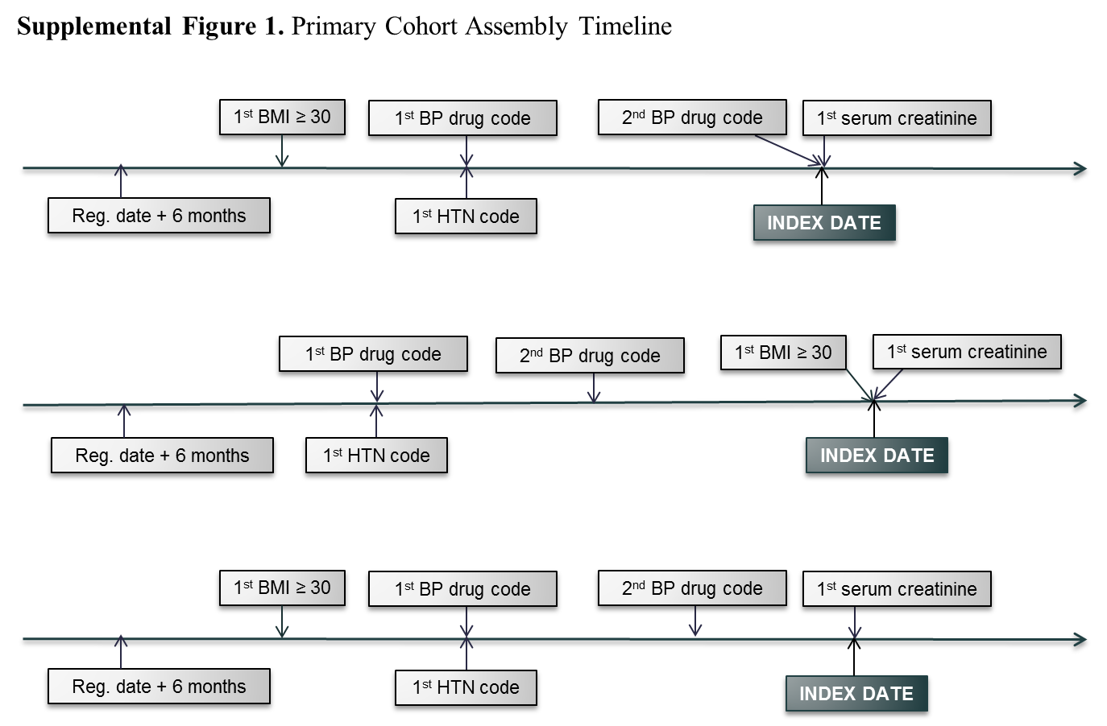

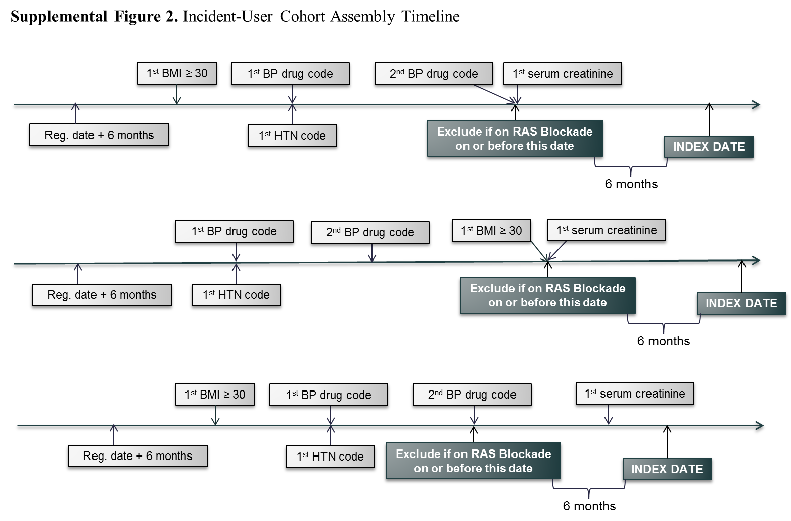

SUPPLEMENTAL MATERIAL REFERENCES

1. THIN Data Statistics. 2014
2. Doran T, Fullwood C, Gravelle H, Reeves D, Kontopantelis E, Hiroeh U, Roland M: Pay-for-performance programs in family practices in the United Kingdom. The New England journal of medicine, 355: 375-384, 2006
3. National Institute for Health and Care Excellence. QS28: Quality standard for hypertension. Manchester, United Kingdom, 2013
4. Haynes K, Bilker WB, TenHave TR, Strom BL, Lewis JD: Temporal and within practice variability in the health improvement network. Pharmacoepidemiology and drug safety, 20: 948-955, 2011
5. Omar RZ, O'Sullivan C, Petersen I, Islam A, Majeed A: A model based on age, sex, and morbidity to explain variation in UK general practice prescribing: cohort study. Bmj, 337: a238, 2008
6. Whitelaw FG, Nevin SL, Milne RM, Taylor RJ, Taylor MW, Watt AH: Completeness and accuracy of morbidity and repeat prescribing records held on general practice computers in Scotland. Br J Gen Pract, 46: 181-186, 1996
7. Pringle M, Ward P, Chilvers C: Assessment of the completeness and accuracy of computer medical records in four practices committed to recording data on computer. Br J Gen Pract, 45: 537-541, 1995
8. Lewis JD, Bilker WB, Weinstein RB, Strom BL: The relationship between time since registration and measured incidence rates in the General Practice Research Database. Pharmacoepidemiology and drug safety, 14: 443-451, 2005
9. Haynes K, Bilker WB, Tenhave TR, Strom BL, Lewis JD: Temporal and within practice variability in the health improvement network. Pharmacoepidemiology and drug safety, 20: 948-955, 2011
10. O'Keeffe AG, Petersen I, Nazareth I: Initiation rates of statin therapy for the primary prevention of cardiovascular disease: an assessment of differences between countries of the UK and between regions within England. BMJ Open, 5: e007207, 2015
11. Denburg MR, Jemielita TO, Tasian GE, Haynes K, Mucksavage P, Shults J, Copelovitch L: Assessing the risk of incident hypertension and chronic kidney disease after exposure to shockwave lithotripsy and ureteroscopy. Kidney international, 2015
12. Chiesa Fuxench ZC, Shin DB, Ogdie Beatty A, Gelfand JM: The Risk of Cancer in Patients With Psoriasis: A Population-Based Cohort Study in the Health Improvement Network. JAMA Dermatol, 152: 282-290, 2016
13. Yeung H, Takeshita J, Mehta NN, Kimmel SE, Ogdie A, Margolis DJ, Shin DB, Attor R, Troxel AB, Gelfand JM: Psoriasis severity and the prevalence of major medical comorbidity: a population-based study. JAMA Dermatol, 149: 1173-1179, 2013
14. Denburg MR, Leonard MB, Haynes K, Tuchman S, Tasian G, Shults J, Copelovitch L: Risk of fracture in urolithiasis: a population-based cohort study using the health improvement network. Clin J Am Soc Nephrol, 9: 2133-2140, 2014
15. Petersen I, McCrea RL, Osborn DJ, Evans S, Pinfold V, Cowen PJ, Gilbert R, Nazareth I: Discontinuation of antipsychotic medication in pregnancy: a cohort study. Schizophr Res, 159: 218-225, 2014
16. Langan SM, Seminara NM, Shin DB, Troxel AB, Kimmel SE, Mehta NN, Margolis DJ, Gelfand JM: Prevalence of metabolic syndrome in patients with psoriasis: a population-based study in the United Kingdom. J Invest Dermatol, 132: 556-562, 2012
17. UK National Health Service: NHS Choices. 2015
18. Lakatos E: Sample sizes based on the log-rank statistic in complex clinical trials. Biometrics, 44: 229-241, 1988
19. Lakatos E: Designing complex group sequential survival trials. Statistics in medicine, 21: 1969-1989, 2002
20. Townsend P: Poverty in the United Kingdom, London, UK, Allen Lane and Penguin Books, 1979
21. Joffe MM, Ten Have TR, Feldman HI, Kimmel SE: Model selection, confounder control, and marginal structural models: Review and new applications. Am Stat, 58: 272-279, 2004
22. Robins JM, Hernan MA, Brumback B: Marginal structural models and causal inference in epidemiology. Epidemiology, 11: 550-560, 2000

