SUPPLEMENTARY MATERIALS
Supplementary Figure 1. Identification and selection process, with reasons for exclusion, of the articles about systemic pharmacological therapy for advanced HCC, leading to the final studies utilized for the Network Meta-Analysis (NMA).
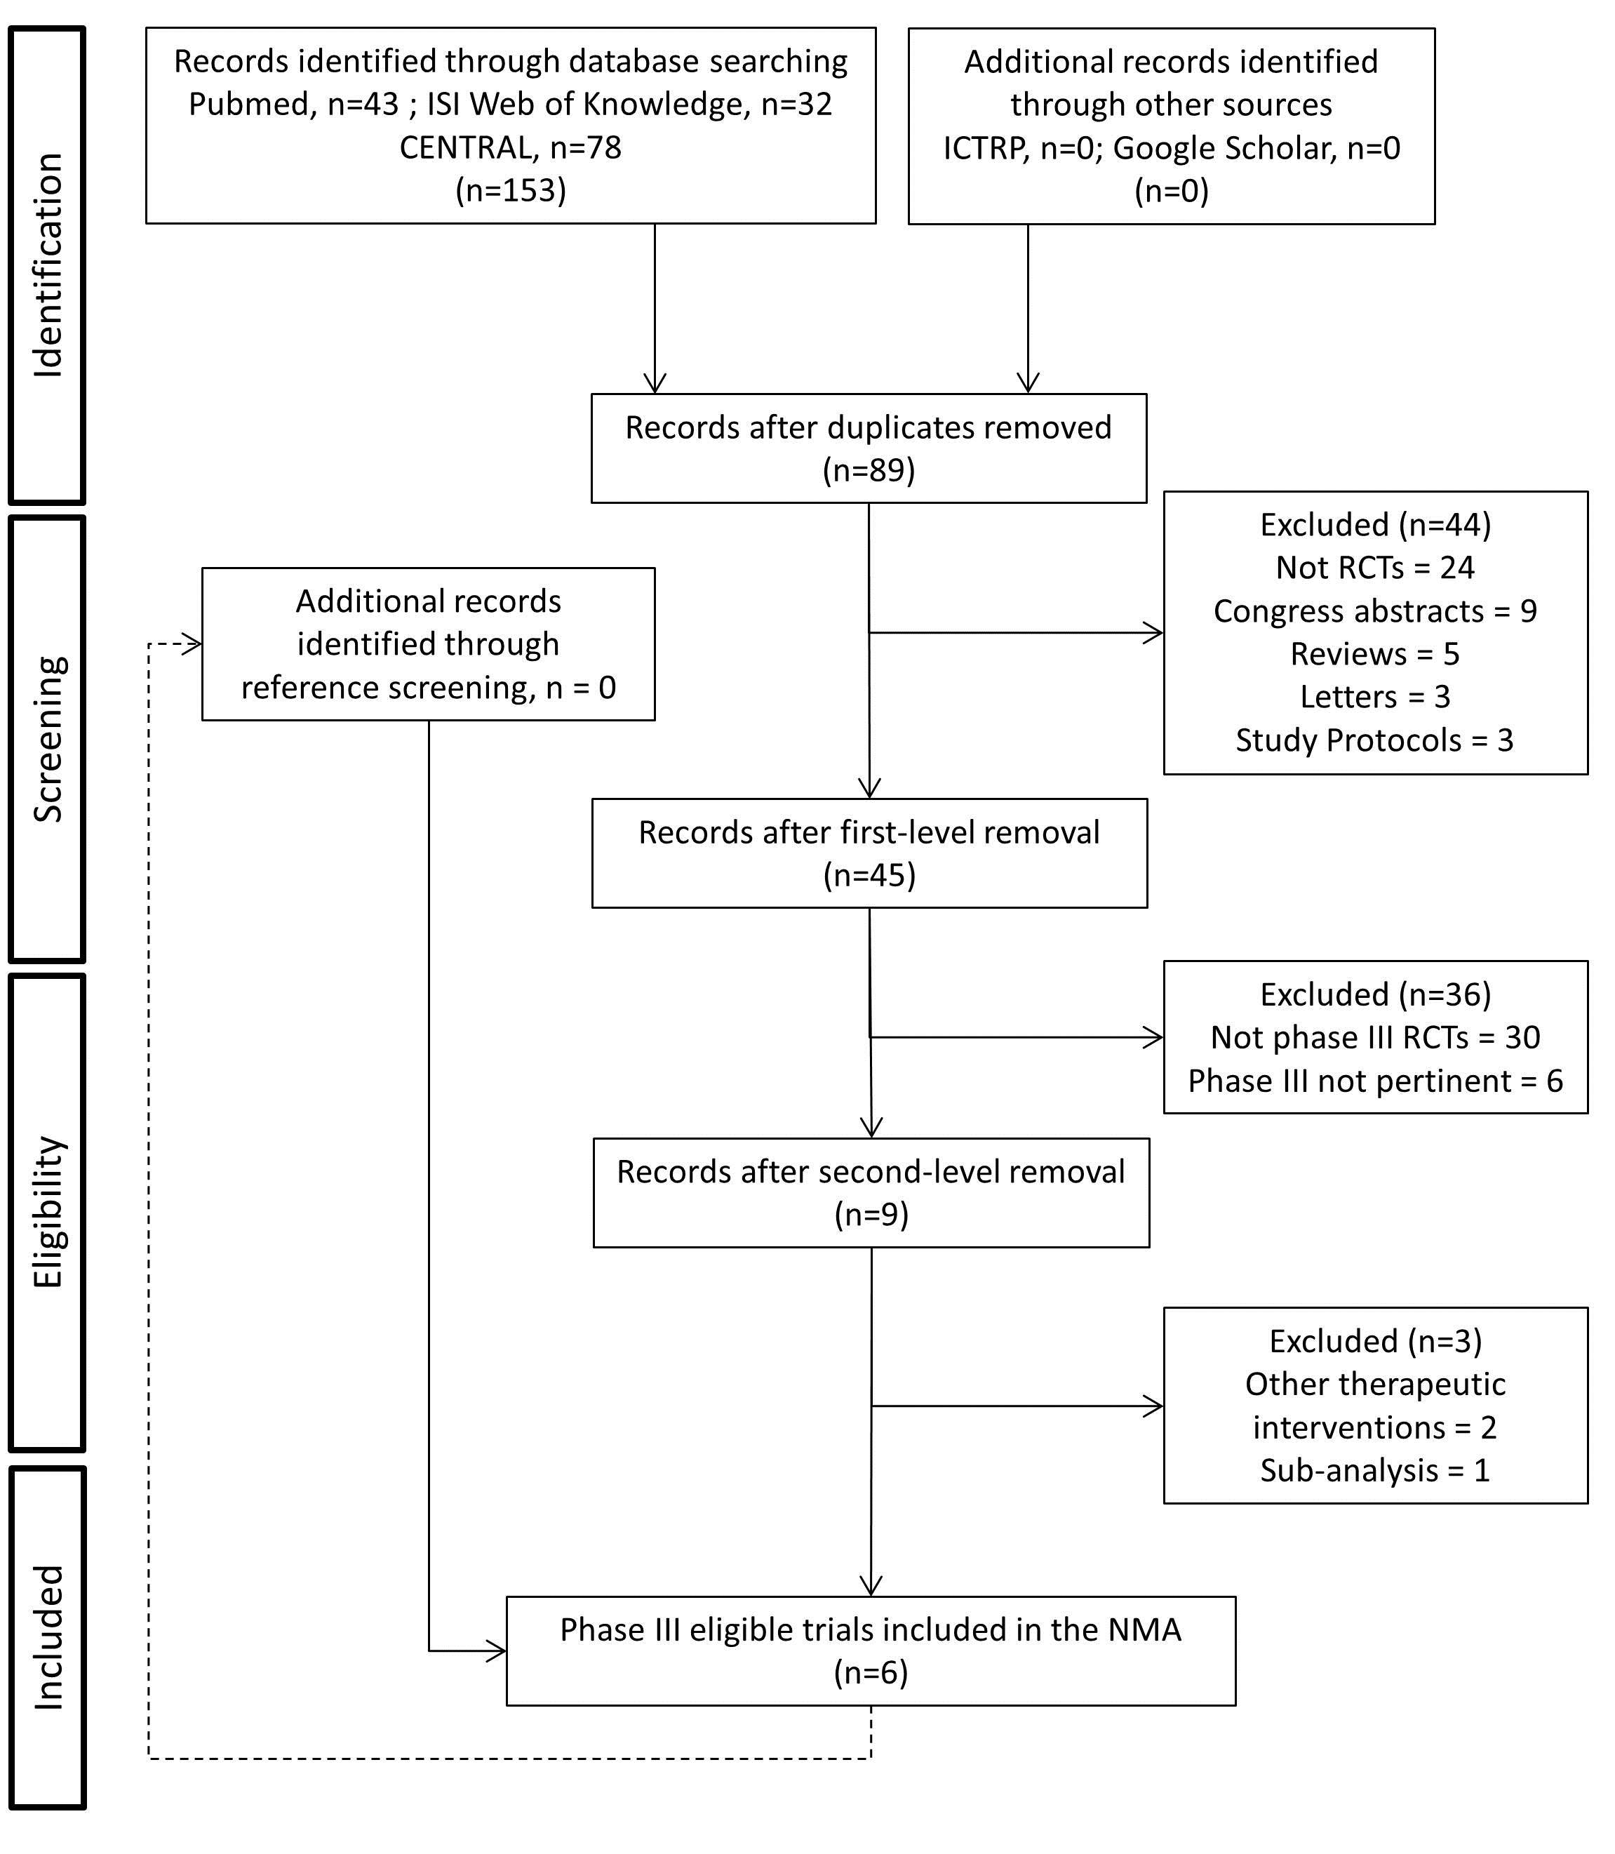

Supplementary Table 1. Results from Literature search and summary of exclusion criteria leading to the 6 phase III RCTs retained for the network meta-analysis.
First Author | Journal | Year; vol: pages | Full paper? | RCT? | Phase III? | Pertinent to the study aim? | Eligibile?
Abou-Alfa GK | Curr Oncol Rep | 2008; 10: 199-205 | Review | NO | NA | NO | NO
Muszbek N | Curr Med Res Opin | 2008; 24: 3559-69 | YES | NO | NA | NO | NO
Llovet JM | NEJM | 2008; 359:378-90 | YES | YES | YES | YES | YES
Hoffmann K | BMC cancer | 2008; 8: 349 | Protocol | YES | YES | NO | NO
Cheng AL | The Lancet | 2009; 10: 25-34 | YES | YES | YES | YES | YES
Detry O | Rev Med Liege | 2009; 64: 168-70 | Protocol | YES | YES | NO | NO
Gusani NJ | Drugs | 2009; 69: 2533-40 | YES | NO | NA | NO | NO
Dufour JF | Oncologist | 2010; 15: 1198-204 | YES | YES | NO | NO | NO
Abou-Alfa GK | JAMA | 2010; 304: 2154-60 | YES | YES | YES | NO | NO
Giacomin A | Hepatol Res | 2010; 40: 153-60 | YES | YES | YES | YES | NO
Lencioni R | Int J Clin Pract | 2010; 64: 1034-41 | YES | NO | NA | YES | NO
Chow, PKH | Br J Cancer | 2011; 105: 945-952 | YES | YES | NO | NO | NO
Guan Y-S | Expert Opin Pharmacother | 2011; 12: 303-13 | YES | NO | NA | NO | NO
Kudo M | Eur J Cancer | 2011; 47: 2117-27 | YES | YES | YES | NO | NO
Salhab M | Hepatology | 2011; 54: 1395A | Abstract | NO | NA | NO | NO
Iavarone M | Hepatology | 2011; 54: 2055-63 | YES | NO | NA | YES | NO
Sansonno D | Oncologist | 2012; 17: 359-66 | YES | YES | NO | NO | NO
Llovet JM | Clin Cancer Res | 2012; 18: 2290-300 | YES | NO | NA | NO | NO
Ren Z | JCO | 2012; 30: abstr 4008 | Abstract | YES | NO | NO | NO
Trojniak MP | Immunopharmacol Immunotoxicol | 2012; 34: 419-22 | YES | NO | NA | NO | NO
Cheng AL | Eur J Cancer | 2012; 48: 1452-65 | YES | NO | NA | NO | NO
Raoul J-L | J Hepatol | 2012; 56: 1080-8 | YES | NO | NA | YES | NO
Bruix J | J Hepatol | 2012; 57: 821-9 | YES | NO | NA | YES | NO
Yang Y | Cell Biochem Biophys | 2012; 63: 159-69 | YES | YES | NO | NO | NO
Wakelee, HA | J Thorac Oncol | 2012; 7: 1574-1582 | YES | YES | NO | NO | NO
Huang Y-H | Chin Med J (Engl) | 2013; 126: 385-6 | YES | NO | NA | NO | NO
Chung, YH | Int J Cancer | 2013; 132: 2448-2458 | YES | YES | NO | NO | NO
Bai W | J Dig Dis | 2013; 14: 181-90 | YES | NO | NA | NO | NO
Santoro A | Lancet Oncol | 2013; 14: 55-63 | YES | YES | NO | NO | NO
Rimassa L | Oncologist | 2013; 18: 379-380 | YES | YES | NO | NO | NO
Tabernero, J | Clin Cancer Res | 2013; 19: 2541-2550 | YES | YES | NO | NO | NO
Heo, J | Nat Med | 2013; 19: 329-336 | YES | YES | NO | NO | NO
Abdel-Rahman O | Med Oncol | 2013; 30: 655 | YES | YES | NO | YES | NO
Bujold, A | JCO | 2013; 31: 1631 | YES | YES | NO | NO | NO
Llovet JM | JCO | 2013; 31: 3509-16 | YES | YES | YES | YES | NO
Johnson PJ | JCO | 2013; 31: 3517-24 | YES | YES | YES | YES | YES
Cheng AL | JCO | 2013; 31: 4067-75 | YES | YES | YES | YES | YES
Kasai K | JCO | 2013; 31: abstr 216 | Abstract | NO | NA | NO | NO
King J | Eur J Cancer | 2013; 49: S622 | Abstract | NO | NA | NO | NO
Duffy A | Hepatology | 2013; 57: 1068-77 | YES | NO | NA | NO | NO
Vouche M | Hepatology | 2013; 58: 1655-66 | YES | YES | NO | NO | NO
Dai X | Eur J Radiol | 2013; 82: 327-34 | YES | NO | NA | NO | NO
Han, GH | Future Oncol | 2013; 9: 403-410 | YES | NO | NA | NO | NO
Rimassa L | Hepat Oncol | 2014; 1: 181-8 | Review | YES | YES | YES | NO
Hagihara A | Cancer Sci | 2014; 105: 354-8 | YES | YES | NO | NO | NO
Vilgrain V | Trials | 2014; 15: 474 | Protocol | NO | NA | NO | NO
Burki TK | Lancet Oncol | 2014; 15: e368 | Letter | NO | NA | NO | NO
Gang Z | HPB (Oxford) | 2014; 16: 298 | Abstract | NO | NA | NO | NO
Qin, SK | Oncologist | 2014; 19: 1169-1178 | YES | NO | NA | YES | NO
Yu SC | Radiology | 2014; 270: 607-20 | YES | YES | NO | NO | NO
Ji YX | Chinese Academy of Medical Sciences | 2014; 29: 7-14 | YES | YES | NO | NO | NO
Zhu AX | JAMA | 2014; 312: 57-67 | YES | YES | YES | NO | NO
Chantharasamee J | JCO | 2014; 32: abstr e15109 | Abstract | NO | NA | NO | NO
Moehler, M | Eur J Cancer | 2014; 50: 3125-3135 | YES | YES | NO | NO | NO
Kudo, M | Hepatology | 2014; 60: 1697-1707 | YES | YES | YES | NO | NO
Kulik L | J Hepatol | 2014; 61: 309-17 | YES | YES | NO | NO | NO
Yin L | J Hepatol | 2014; 61: 82-8 | YES | YES | NO | NO | NO
Bolos D | J Hepatol | 2014; 61: 947-50 | Review | NO | NA | NO | NO
Nakashita S | Hepatology Int | 2014; 8: S264-S265 | Abstract | NO | NA | NO | NO
Hyun MH | Hepatology | 2015: 62: 980-0 | Letter | YES | NO | NO | NO
Rimassa L | Tumori | 2015; 101: 139-43 | YES | NO | NA | NO | NO
Gholam P | CAH&O | 2015; 13: 232-4 | Letter | NO | NA | NO | NO
Breitbach CJ | Methods Mol Biol | 2015; 1317: 343-57 | YES | YES | NO | NO | NO
Hoffmann K | BMC cancer | 2015; 15: | YES | YES | YES | NO | NO
Zhu AX | Lancet Oncol | 2015; 16: 859-70 | YES | YES | YES | YES | NO
Bruix J | The Lancet | 2015; 16: 1344-54 | YES | YES | YES | NO | NO
Kan X | Eur Rev Med Pharmacol Sci | 2015; 19: 247-55 | YES | NO | NA | NO | NO
Corona-Villalobos CP | Eur Radiol | 2015; 25: 380-90 | YES | NO | NA | NO | NO
Kang, YK | Ann Oncol | 2015; 26: 2457-2463 | YES | YES | NO | NO | NO
Pinter, M | Radiology | 2015; 277: 903-912 | YES | YES | NO | NO | NO
Duvoux C | Transplant Rev (Orlando) | 2015; 29: 168-74 | Review | NO | NA | NO | NO
Li J | Med Oncol | 2015; 32: 238 | YES | NO | NA | NO | NO
Cainap C | JCO | 2015; 33: 172-9 | YES | YES | YES | YES | YES
Johnson PJ | JCO | 2015; 33: 550-8 | YES | NO | NA | NO | NO
Zhu AX | JCO | 2015; 33: 559-66 | YES | YES | YES | YES | YES
Ren Z | JCO | 2015; 33: 894-900 | YES | YES | NO | NO | NO
Ricke J | Liver Int | 2015; 35: 620-6 | YES | NO | NA | NO | NO
Okusaka T | Hepatol Res | 2015; 45: 1283-91 | YES | YES | NO | NO | NO
Wang C | Hepatology | 2015; 62: 389A | Abstract | YES | NA | NO | NO
Cheng AL | J Hepatol | 2015; 63: 896-904 | YES | YES | NO | YES | NO
Ye S-L | Oncotarget | 2015; 7: 6639-48 | YES | NO | NA | NO | NO
Liu B | Oncology | 2015; 89: 23-30 | YES | YES | NO | NO | NO
Zhu, AX | Clin Cancer Res | 2016; 22: 4870-4879 | YES | NO | NA | NO | NO
Yu JI | World J Gastroenterol | 2016; 22; 6851-63 | Review | NO | NA | NO | NO
Ciuleanu T | Ann Oncol | 2016; 27: 680-7 | YES | YES | NO | YES | NO
Koeberle D | Ann Oncol | 2016; 27: 856-61 | YES | YES | NO | YES | NO
Lencioni R | J Hepatol | 2016; 64: 1090-8 | YES | YES | NO | NO | NO
Rangegowda D | J Hepatol | 2016; 64: S691 | Abstract | YES | NO | YES | NO
Abou-Alfa, GK | J Hepatol | 2016; 65: 289-295 | YES | YES | NO | YES | NO

Supplementary Table 2. Detailed characteristics of grade 3-4 adverse events reported in the 6 studies included in the network meta-analysis.
Author, year | Treatment | Vomiting | Fatigue | Liv Disf | Hypertension | HFS | Diarrhea
Llovet, 2008 | Sorafenib | 3 (1.0%) | 12 (4.0%) | 1 (0.4%) | 6 (2.0%) | 24 (8.0%) | 24 (8.0%)
 | Placebo | 3 (1.0%) | 11 (3.5%) | 0 (0.0%) | 3 (1.0%) | 2 (0.5%) | 6 (2.0%)
Cheng, 2009 | Sorafenib | 0 (0.0%) | 5 (3.4%) | 0 (0.0%) | 3 (2.0%) | 16 (10.7%) | 9 (6.0%)
 | Placebo | 0 (0.0%) | 1 (1.3%) | 0 (0.0%) | 0 (0.0%) | 0 (0.0%) | 0 (0.0%)
Johnson, 2013 | Sorafenib | 3 (0.5%) | 40 (7.0%) | 98 (17.0%) | 30 (5.3%) | 86 (15.0%) | 40 (7.0%)
 | Brivanib | 17 (3.0%) | 83 (14.5%) | 86 (15.0%) | 76 (13.3%) | 12 (2.0%) | 35 (6.0%)
Cheng, 2013 | Sorafenib | 7 (1.3%) | 21 (3.9%) | 49 (9.0%) | 15 (2.8%) | 115 (21.2%) | 49 (9.0%)
 | Sunitinib | 14 (2.7%) | 33 (6.3%) | 46 (8.7%) | 20 (3.8%) | 70 (13.3%) | 38 (7.2%)
Cainap, 2015 | Sorafenib | 4 (0.8%) | 25 (4.8%) | 65 (12.5%) | 45 (8.7%) | 77 (14.8%) | 48 (9.2%)
 | Linifanib | 22 (4.3%) | 49 (9.6%) | 62 (12.2%) | 106 (20.8%) | 70 (13.7%) | 61 (12.0%)
Zhu, 2015 | Sorafenib (+ Placebo) | 7 (2.0%) | 62 (17.5%) | 42 (11.8%) | 31 (8.7%) | 62 (17.5%) | 42 (11.8%)
 | Sorafenib + Erlotinib | 8 (2.2%) | 64 (17.7%) | 50 (13.8%) | 17 (4.7%) | 37 (10.2%) | 92 (25.4%)

Abbreviations: Liv disf = liver dysfunction; HFS = hand-foot syndrome

Supplementary Table 3. Mean ranks and probabilities (in parentheses) of being the most safety therapy based on SUCRA values.
Grade 3-4 AE | Plac | Sor | Sor + ERL | Sun | Bri | Lin
Vomiting | 2.3 (40.9%) | 2.0 (28.4%) | 2.3 (27.4%) | 3.7 (3.2%) | 5.4 (0.0%) | 5.3 (0.1%)
Fatigue | 1.7 (65.5%) | 2.2 (14.1%) | 2.3 (18.8%) | 4.3 (1.6%) | 5.3 (0.0%) | 5.1 (0.0%)
Liver dysfunction | 3.1 (51.7%) | 3.8 (0.8%) | 4.8 (2.7%) | 3.3 (13.7%) | 2.6 (21.0%) | 3.4 (10.1%)
Hypertension | 1.6 (58.4%) | 3.1 (0.2%) | 1.6 (41.3%) | 3.9 (0.1%) | 5.5 (0.0%) | 5.4 (0.0%)
HFS | 1.1 (86.3%) | 5.7 (0.0%) | 3.4 (0.0%) | 3.6 (0.0%) | 1.9 (13.7%) | 5.2 (0.0%)
Diarrhea | 1.0 (99.8%) | 3.7 (0.0%) | 6.0 (0.0%) | 2.6 (0.5%) | 2.9 (0.1%) | 4.8 (0.0%)

Abbreviations: Sor = Sorafenib; ERL = Erlotinib; Lin = Linifanib; Bri = Brivanib; Sun = Sunitinib; Plac = Placebo; HFS = hand-foot syndrome

Supplementary Table 4. Main mechanisms of action of the drugs included in the present network meta-analysis. Data obtained from https://www.drugbank.ca and cited references below.

Drug molecule | Mechanism of action | Notes
Sorafenib | Sorafenib is a small molecular inhibitor of Raf kinase (more avidly C-Raf than B-Raf), PDGF, VEGF receptor 2 & 3 kinases and c Kit the receptor for Stem cell factor | The originality of Sorafenib lays in its simultaneous targeting of the Raf/Mek/Erk pathway. Considered a multikinase inhibitor
Erlotinib | Erlotinib inhibits the intracellular phosphorylation of tyrosine kinase associated with the EGF receptor. It binds in a reversible fashion to the adenosine triphosphate (ATP) binding site of the receptor* | Specificity of inhibition with regard to other tyrosine kinase receptors has not been fully characterized. EGFR is expressed on the cell surface of normal cells and cancer cells. Considered an endotelial cell proliferation inhibitor in connection with antiangiogenesis.
Linifanib | Linifanib is a potent inhibitor of receptor tyrosine kineases (RTK), VEGF and PDGF with IC50 of 0.2, 2, 4, and 7 nM for human endothelial cells, PDGF receptor beta (PDGFR-β), KDR, and colony stimulating factor 1 receptor (CSF-1R), respectively. It has much less activity (IC50s > 1 μM) against unrelated RTKs, soluble tyrosine kinases, or serine/threonine kinases
Sunitinib | Sunitinib inhibits platelet-derived growth factor receptors (PDGF-R), vascular endothelial growth factor receptors (VEGF-R) and FGF receptor (FGF-R). Sunitinib also inhibits KIT (CD117), RET, CSF-1R, and flt3 | Considered mainly a VEGF/VEGF-R inhibitor
Brivanib | Brivanib is an ATP-competitive inhibitor of human VEGFR-2, with an IC50 of 25 nmol/L and Ki of 26 nmol/L. In addition, it inhibits VEGRFR-1 (IC50 = 380 nmol/L) and VEGRFR-3 (IC50 = 10 nmol/L). Brivanib also showed good selectivity for FGFR-1 (IC50 = 148 nmol/L), FGFR-2 (IC50 = 125 nmol/L), and FGFR-3 (IC50 = 68 nmol/L). Furthermore, it has been shown to selectively inhibit the proliferation of endothelial cells stimulated by VEGF and FGF in vitro with IC50 values of 40 and 276 nmol/L, respectively *** | Considered a multikinase inhibitor

Abbreviations: FGF=Fibroblast growth factor; IC50= half maximal inhibitory concentration; PDGF= platelet-derived growth factor ; RTK= receptor tyrosine kinase; VEGF=Vascular endothelial growth factor.
All:
Chimote G, Comparison of effects of anti-angiogenic agents in the zebrafish efficacy–toxicity model for translational anti-angiogenic drug discovery Drug Des Devel Ther. 2014; 8: 1107–1123,
Sorafenib:
Wilhelm SM, Adnane L, Newell P, Villanueva A, Llovet JM, Lynch M (October 2008). Preclinical overview of sorafenib, a multikinase inhibitor that targets both Raf and VEGF and PDGF receptor tyrosine kinase signaling". Mol. Cancer Ther. 7 (10): 3129–40
Erlotinib:
Raymond E, Faivre S, Armand J. Epidermal growth factor receptor tyrosine kinase as a target for anticancer therapy. Drugs. 2000;60 Suppl 1: 15–23
Linifanib:
Albert DH, Tapang P, Magoc T, et al. Preclinical activity of ABT-869, a multitargeted receptor tyrosine kinase inhibitor. Molecular Cancer Therapeutics. 2006;5:995–1006
Guo J, Marcotte PA, McCall J et al. Inhibition of phosphorylation of the colony-stimulating factor-1 receptor (c-Fms) tyrosine kinase in transfected cells by ABT-869 and other tyrosine kinase inhibitors. Molecular Cancer Therapeutics. 2006;5:1007–1013
Sunitinb:
O'Farrell AM, Abrams TJ, Yuen HA, et al. SU11248 is a novel FLT3 tyrosine kinase inhibitor with potent activity in vitro and in vivo. Blood. 2003;101:3597-605.
Mendel DB, Laird AD, Xin X, et al. In vivo antitumor activity of SU11248, a novel tyrosine kinase inhibitor targeting vascular endothelial growth factor and platelet-derived growth factor receptors: determination of a pharmacokinetic/pharmacodynamic relationship. Clin Cancer Res. 2003;9:327-37
Brivanib:
Ayers M, Fargnoli J, Lewin A, et al. Discovery and Validation of Biomarkers that Respond to Treatment with Brivanib Alaninate, a Small-Molecule VEGFR-2/FGFR-1 Antagonist. Cancer Research 2007;67:6899–6906
Bhide RS, Cai ZW, Zhang YZ et al. Discovery and Preclinical Studies of (R)-1-(4-(4-Fluoro-2-methyl-1H-indol-5-yloxy)-5- methylpyrrolo[2,1-f][1,2,4]triazin-6-yloxy)propan- 2-ol (BMS-540215), an in Vivo Active Potent VEGFR-2 Inhibitor". Journal of Medicinal Chemistry 2006;49:2143–2146
Cai ZW, Zhang Y, Borzilleri RM, et al: Discovery of brivanib alaninate ((S)-((R)-1-(4-(4-fluoro-2-methyl-1H-indol- 5-yloxy)-5-methylpyrrolo[2,1-f][1,2,4] triazin-6- yloxy)propan-2-yl)2-aminopropanoate), a novel prodrug of dual vascular endothelial growth factor receptor-2 and fibroblast growth factor receptor-1 kinase inhibitor (BMS- 540215). J Med Chem 51:1976-1980, 2008

Supplementary Figure 2. RoB 2.0 tool for risk of bias assessment.
